Devin Lim

DATA 5322 Written Homework 1: Decision Trees

April 26, 2024

Correlates of Alcohol Consumption Among Youth

## Abstract

Youth substance use can lead to various short-term problems and may “develop into lifelong issues such as substance dependence, chronic health problems, and social and financial consequences”1. The National Survey on Drug Use and Health (NSDUH), which started in 1971 and became an annual survey in 1990, “is the primary nationally representative source of annual estimates of drug use and mental illness … in the United States”2. Using the data from 2020 NSDUH, this paper examined the top factors that are correlated with youth (aged 12 to 17) alcohol use by utilizing various machine learning methods. Results show that there is 1 common predictor across the substance use variables we analyzed: whether the youth’s student peers also drink. Aside from that, the top factors are multifaceted, ranging from violence (when predicting a youth’s age at the time of first drink), to peer influence (when predicting whether a youth has ever drunk), to socioeconomic factors like income and country (when predicting chronic drinking in youth).

## Introduction

Alcohol is our youth’s drug of choice; it is consumed more frequently than either tobacco or marijuana. Youth also binge drink more often compared to adults – 90% of alcoholic beverages consumed by youth are consumed during acts of binge drinking. This behavior is linked to increased risk of injuries, death, physical and sexual assault, learning difficulties, and alcohol problems later in life.3 As such, it is crucial to understand the factors that are correlated with youth drinking so that it may inform our policies and approach to harm reduction.

The dataset used in this analysis is a subset of the 2020 NSDUH4 that has been processed by Dr. Mendible5 to include only youth data ages 12 to 17 consisting 79 out of the 2,890 variables. The variables include substance usage statistics for alcohol, marijuana, and cigarettes along with demographic data such as household income, peer influence, and parental involvement.

Various machine learning algorithms and training approaches are compared and utilized to uncover factors most correlated to youth drinking. More specifically, we are looking for factors related to ‘iralcage’ (the age a youth first consumed alcohol), ‘alcflag’ (whether a youth has ever consumed alcohol), and ‘alcydays’ (the number of days a youth has consumed alcohol within the past year). These factors are then discussed to provide us with usable insights. Background information on the data preparation process and machine learning methods is provided below.

## Background

### Null Model

The Null Model serves as a baseline in both regression and classification problems. In regression, it always predicts the mean of the response variable. In classification, it always predicts the most frequent class. It is important to compare the models we build against the Null Model to ensure that our models provide real benefits over the simplest possible baseline.

### Ordinary Least Squares

Ordinary Least Squares is the earliest form of linear regression6. This method aims to create a best fit line such that the distance between the points and the line (known as the residuals) is minimized. The best fit line is defined by a set of constants acting as weights to the predictors and an irreducible error. OLS requires many assumptions to be met about the data, such as the linearity between predictor and response and no collinearity between predictors.

$$\hat{y}=β_{0}+β_{1}x_{1}+β_{2}x_{2}+…+β_{p}x_{p} + ϵ$$

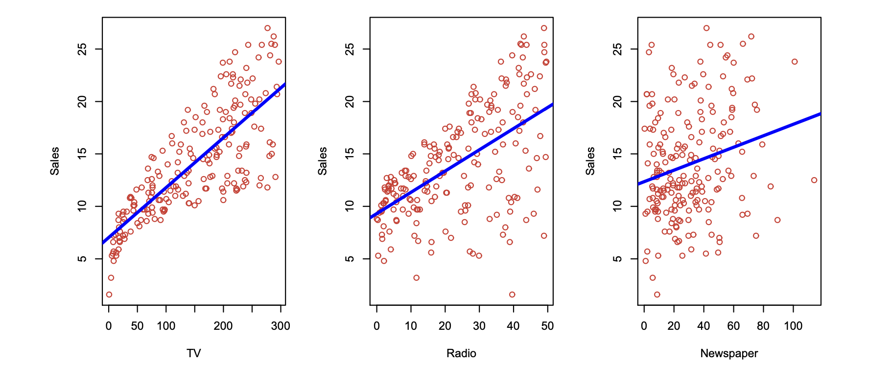Figure 1. Ordinary Least Squares Regression.6

### Lasso

The Lasso model adds a penalty term to Ordinary Least Squares. This penalty term is the sum of the absolute values of the coefficients multiplied by the tuning parameter λ. This encourages the model to shrink coefficients as much as possible, often to zero, which improves model interpretability (it performs variable selection). Unlike Ordinary Least Squares, Lasso can handle collinearity between predictors.

$$\sum_{i=1}^{n}{{\left(y_{i}-β_{0}-\sum_{j=i}^{p}{β_{j}x_{ij}}\right)}^{2}}+λ\sum_{j=1}^{p}{\left|β_{j}\right|}=RSS+λ\sum_{j=1}^{p}{\left|β_{j}\right|}$$

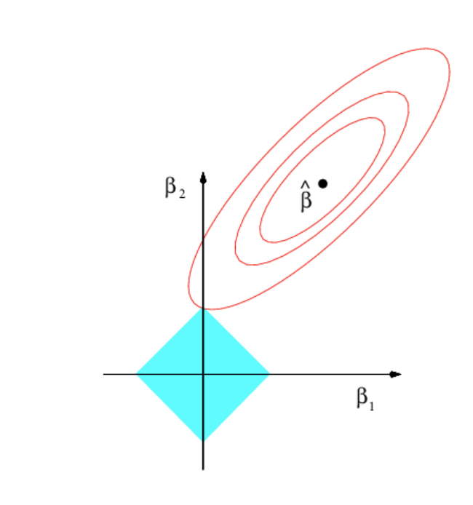

Figure 2. Lasso Regression.6

### Decision Tree Model

A Decision Tree is a model built through a supervised learning approach that splits recursively on the most important feature. It is a greedy approach, and thus it’s deterministic. Decision Trees are flexible; It is applicable to both regression and classification problems with either categorical or numerical features and it can also handle non-linear relationships between the feature and response variables. However, since it’s deterministic, it’s prone to overfitting.

Compared to later Tree-based models, being a single tree trained on the full training set and features mean that they are much more interpretable. For example, in Figure 3, the most important feature and its direction of correlation is easily understood: if they don’t have feathers, they are not a bird species.

Decision Trees can be tuned by adjusting its maximum depth and the minimum number of samples a node must have before it’s allowed to split. A shallower tree and a higher minimum number of samples help to prevent overfitting.

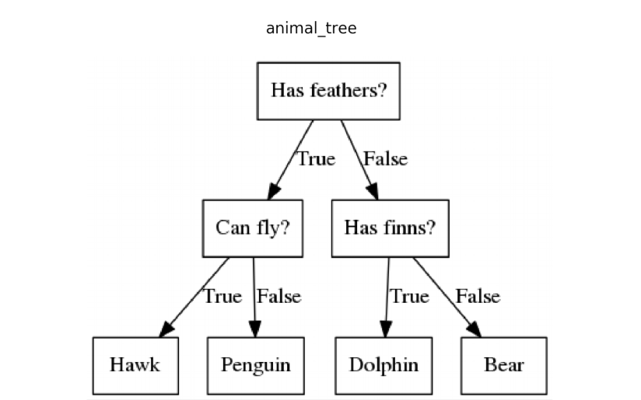

Figure 3. A decision tree.7

### Bagging Model

A Bagging Model trains multiple decision trees on different samples (obtained through bootstrap sampling) of the dataset then aggregates their predictions to obtain a final prediction (this approach of aggregating multiple models is also known as an Ensemble Method). As a result of random sampling, it is no longer deterministic and reduces overfitting. Being an Ensemble Tree, interpretation is much more difficult as analyzing a single tree will not provide a correct interpretation of the whole model. Feature importance can be calculated through statistical methods but determining the direction of the relationship is difficult.

Bagging Models can be tuned similarly to Decision Trees by adjusting its maximum depth and minimum number of samples, but additionally, we can also adjust the number of trees built for the ensemble. More trees generally further prevent overfitting, but since it is computationally expensive and there are diminishing returns, it is important to test many variations and find a balance.

While no bagging models are used in this analysis directly, later models like the Random Forest builds upon this concept.

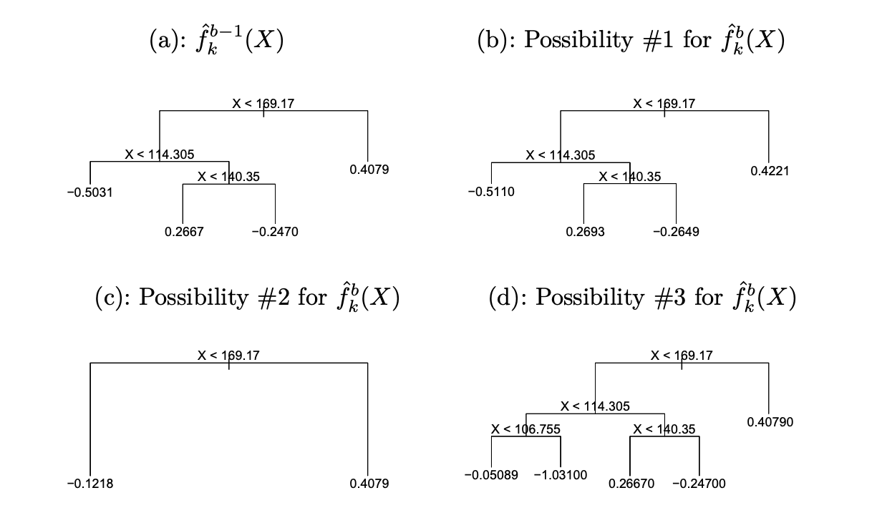

Figure 4. Ensemble Learning Method.6

### Random Forest

Random Forest learning is an ensemble learning method like bagging but in addition to training multiple models on different samples, it also selects a random subset of features on each split. This allows Random Forest Trees to handle higher dimensional data better than Bagging Trees, further reduces overfitting by reducing the correlation between trees, and generally improve predictions. However, it is even more computationally expensive than Bagging Trees.

Random Forest Models can be tuned by adjusting all the same parameters as Bagging Models, with the addition of the number of features allowed at each split. Lower values reduce variance and reduces overfitting.

### Gradient Boost

Gradient Boosted Trees are Ensemble Trees like Random Forest, but rather than training separate, independent trees before finally aggregating their predictions, Gradient Boost learning trains each tree sequentially through correcting mistakes made by previous models (e.g. in a classification problem, it will consider misclassified datapoints to train future models). Gradient Boost often results in better performance, but since it is not parallelizable, it can take significantly longer to train even when compared to Random Forest Trees.

A Gradient Boosted Tree can be tuned by adjusting all the same parameters as a Random Forest Tree, with the addition of the learning rate, which scales the contribution of each new model to the final prediction. A higher learning rate means that the model grows “faster” (i.e. changes more between each tree), allowing the model to fit closer to the training data and therefore increases variance. The learning rate is closely tied to the number of trees in the ensemble – a low learning rate combined with a small number of trees mean that the model will not learn much about the data and therefore may perform worse (i.e. underfitting).

### Methodology

### Data Preparation

Each variable’s value in the NSDUH data is encoded, with their meanings provided in a Codebook2. Some variables are numerical with certain values reserved for special meanings (see Figure 4), while others are a mix of categorical and special meanings. Furthermore, some variables were numerical, some were ordinal, and some were nominal. Due to this, extensive data cleanup was required.   
  
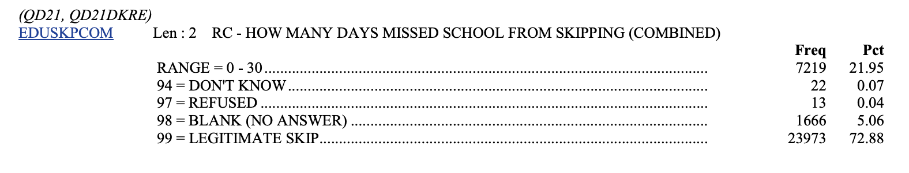

Figure 5. NSDUH Codebook Example.2

The data cleanup process starts with splitting variables into “substance” columns and “demographic” columns, treating “substance” as a pool of response variables to choose from and “demographic” as all our predictor variables. Then we define a list containing values to be treated as a “missing value” so that they may be imputed (such as 94, 97, 98, and 99 for ‘EDUSKPCOM’ as shown in Figure 5). Then variables are categorized as numerical/ordinal/nominal. Finally, we manually special cases such as ‘EDUSCHLGO’ whose value of 11 was merged with 1 (11 means “Yes” with some uncertainty) and ‘EDUSCHGRD2’ which was removed from being a predictor for ‘iralcage’ as it is essentially a proxy for age where the response variable is highly correlated to age.

The imputation process uses an Iterative Imputer with a Random Forest Classifier (as it makes few assumptions about the data and the data to be imputed is categorical) estimator to impute missing values for each predictor using all other predictor. This is done to retain as much data as possible since many of our predictors have missing values in different rows. We are also able to confirm that the imputed values are statistically similar to the rest of the data (see Figure 6 and 7). After imputation, some columns were one-hot encoded (as most of the data are already encoded ordinally or are binary).

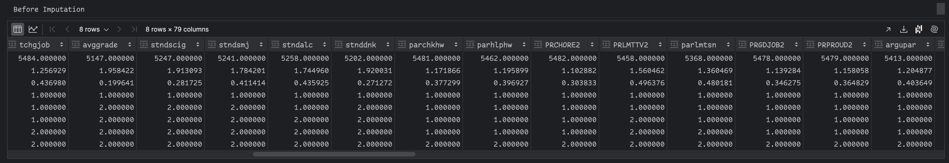

Figure 6. Statistical summary before imputation

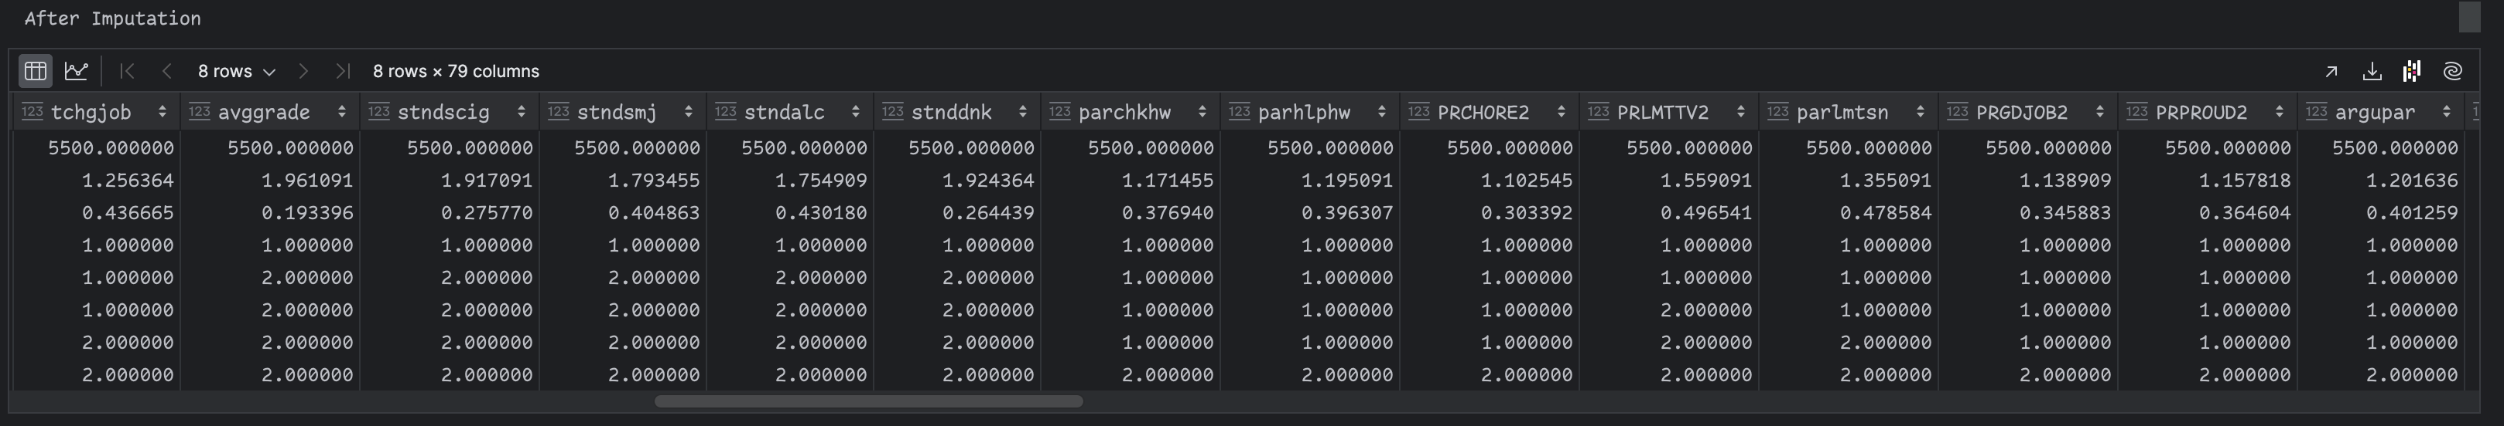

Figure 7. Statistical summary after imputation

### Modeling

For each response variable analyzed (‘iralcage’, ‘alcflag’, and ‘alcydays’), we trained a Random Forest model and compared it with a Null Model plus at least 1 other appropriate model (such as Lasso, Decision Trees, and Gradient Boosting). Every model except for the Null Model was trained with all predictors and tuned with Grid Search 5-fold Cross Validation, either sequentially with 1 hyperparameter at a time or exhaustively with multiple hyperparameters at a time. All models were trained and tested on a 70-30 split dataset.

## Results

### ‘iralcage’ - The age a youth first consumed alcohol

|  |  |
| --- | --- |
| Model | Test MSE |
| Random Forest Regression | 5.41 |
| Null Model | 5.91 |
| Ordinary Least Squares | 5.42 |
| Lasso Model | 5.35 |

Table 1. Test MSE results predicting ‘iralcage’ by Model

Figure 8. ‘iralcage’ most important features in a Lasso Model.

|  |  |  |
| --- | --- | --- |
| Predictor | Description | Coefficient |
| YOATTAK2 | Youth attacked with intent to seriously harm | 0.625647 |
| YOFIGHT2 | Youth had serious fight at school/work | 0.623463 |
| STNDALC | Youth’s knowledge of other students’ drinking | -0.594024 |
| YOGRPFT2 | Youth fought with group vs other group | 0.472173 |
| NEWRACE2_6 | Youth of mixed race (non-hispanic) | -0.353626 |

Table 2. Top 5 predictors for ‘iralcage’.

### ‘alcflag’ - Whether a youth has ever consumed alcohol

|  |  |
| --- | --- |
| Model | Accuracy Score |
| Null Model | 0.76 |
| Decision Tree | 0.8145 |
| Random Forest Classifier | 0.8170 |
| Gradient Boosting Classifier | 0.8273 |

Table 3. Accuracy results predicting ‘iralflag’ by Model.

|  |  |  |
| --- | --- | --- |
| Predictor | Description | Importance |
| YFLMJMO | Youth’s feelings about peers using marijuana monthly | 0.4652 |
| STNDALC | Youth’s knowledge of other students’ drinking | 0.2425 |
| EDUSCHGRD2 | Youth’s grade in school | 0.0615 |
| PRALDLY2 | Whether parents strongly disapprove of 1-2 drinks a day | 0.0395 |
| FRDMJMON | How youth’s close friends feel about the youth using marijuana monthly | 0.0349 |

Table 4. ‘iralflag’ most important features in a Decision Tree.



Figure 9. ‘alcflag’ Decision Tree using only top 5 predictors.

### ‘alcydays’ - Number of days a youth has consumed alcohol within the past year

|  |  |
| --- | --- |
| Model | Accuracy Score |
| Random Forest Classifier | 0.6079 |
| Null Model | 0.6049 |
| Gradient Boosting Classifier | 0.6049 |

Table 5. Accuracy results predicting ‘alcydays’ by Model.

|  |  |  |
| --- | --- | --- |
| Predictor | Description | Importance |
| EDUSCHGRD2 | Youth’s grade in school | 0.065901 |
| HEALTH2 | Youth’s health condition | 0.058377 |
| COUTYP4 | Youth’s county’s metro/nonmetro status | 0.051380 |
| INCOME | Youth’s total family income | 0.041730 |
| STNDALC | Youth’s knowledge of other students’ drinking | 0.032699 |

Table 6. ‘alcydays’ most important features in a Random Forest Tree.

## Discussion

### Tuning

We were curious whether performing cross-validation one parameter at a time would perform better than performing cross-validation with all parameters at once. The motivation was that if performing cross-validation one parameter at a time perform similarly or better, that would be preferable as the search space would be explored sequentially rather than exhaustively, making it much faster. To this end, for each of the response variables above, we cross-validated a Random Forest Model both by single-parameter tuning and multi-parameter tuning. We find that in all cases the single-parameter tuned model performed similarly or better, and often resulted in a less complex model. This is not a focus of this paper and further exploration may be helpful.

### ‘iralcage’ - The age a youth first consumed alcohol

‘iralcage’ is a numerical column with a possible value of 1-66 and 991 (indicating never used alcohol). We trained various cross-validated models against ‘iralcage’ using all demographic columns and obtained a result showing that the Lasso Model performed best (see Table 1). Therefore, we used the Lasso Model to determine which factors are most important (see Table 2).

The top four predictors (Youth attacked with intent to seriously harm, Youth had serious fight at school/work, Youth’s knowledge of other students’ drinking, Youth fought with group vs other group) are binary variables, where 1 is generally a negative (such as youth **has** attacked with intent to seriously harm) and 2 is generally a positive (such as none/few of other students drink alcohol). Since ‘iralcage’ corresponds to age, a positive correlation means that youth who are not involved in violent acts can be expected to have started drinking later in life. The 5th predictor (Youth of mixed race, non-hispanic) must be treated with caution. It is likely that there are underlying socioeconomic, cultural, or environmental factors associated with this correlation, and we would be good to remember that correlation does not equal causation.

### ‘alcflag’ - Whether a youth has ever consumed alcohol

‘alcflag’ is a binary categorical variable with a possible value of 0 (indicating never used) and 1 (indicating ever used). We trained various cross-validated models against ‘alcflag’ using all demographic columns and obtained a result showing that the gradient boosted tree performed best (see Table 3). However, for exploration purposes, we will select a basic decision tree to examine.

The top five predictors in order (see Table 4) are: “Youth’s feelings about peers using marijuana monthly”, “Youth’s knowledge of other students’ drinking”, “Youth’s grade in school”, “Whether parents strongly disapprove of 1-2 drinks a day”, “How youth’s close friends feel about the youth using marijuana monthly”, which are mostly related to peer/parental influence.

Examining the decision tree (see Figure 9) can tell us the direction of correlation. For example, by tracing the left-most branch, we can see that youth whose peers disagree with monthly marijuana use, whose peers don’t drink, whose parents disagree with youth drinking, and in 7th grade or lower is predicted to not have drunk alcohol ever.

### ‘alcydays’ - Number of days a youth has consumed alcohol within the past year

‘alcydays’ is a multi-class categorical variable with a possible value of 1 (1-11 days), 2 (12-49 days), 3 (50-99 days), 4 (100-299 days), 5 (300-365 days), and 6 (no past year use, though this is removed from the data). We trained various cross-validated models against ‘alcydays’ using all demographic columns and obtained a result showing that Random Forest Classifier performed best (see Table 5). Therefore, we used it to determine which factors are most important (see Table 6). However, unlike the Lasso Model or the Decision Tree, an Ensemble Tree is much harder to interpret as we cannot interpret the model based only on a single tree instance, so we are unable to establish the direction of the correlation.

The top five predictors in order are: “Youth’s grade in school”, “Youth’s health condition”, “Youth’s county’s metro/nonmetro status”, “Youth’s total family income”, “Youth’s knowledge of other students’ drinking”.

Unlike the response variable from previous section, chronic drinking is less (though still) influenced by peer group and more influenced by socioeconomic factors such as income and the county that the youth reside in.

### The Importance of Proper Encoding

Under the ‘Methodology’ section it was mentioned that variables were encoded depending on their category as a numerical/ordinal/nominal variable. This is necessary because when dummies are being created, you must not treat an ordinal variable as a binary variable since that implies that each category are independent to one another and will cause misinterpretation or wrong results.

### Conclusion

This analysis shows that the factors that correlate with underage drinking are multi-faceted, the only common predictor among them being whether youth’s student peer also drink. Aside from that, the best predictors for a youth’s age at the time of first drink are mostly related to violence, while the best predictors for a youth’s having ever had a drink are mostly related to their peer group, and, perhaps most concerning of all, the best predictors for chronic drinking in youths are socioeconomic factors like income and county.

Future analysis may be useful to uncover more trends between the demographic variables and the substance use variables. There are likely to be similarities between, for example, factors that cause youth to try alcohol and to try marijuana for the first time. Future analysis should also focus on uncovering the underlying causes that affect one racial group disproportionately.

## References

1. Substance use/misuse [Internet]. [cited 2024 Apr 15]. Available from: https://youth.gov/youth-topics/substance-abuse
2. 2020 NATIONAL SURVEY ON DRUG USE AND HEALTH [Internet]. [cited 2024 Apr 16]. Available from: https://www.datafiles.samhsa.gov/sites/default/files/field-uploads-protected/studies/NSDUH-2020/NSDUH-2020-datasets/NSDUH-2020-DS0001/NSDUH-2020-DS0001-info/NSDUH-2020-DS0001-info-codebook.pdf
3. Get the facts about underage drinking [Internet]. U.S. Department of Health and Human Services; [cited 2024 Apr 15]. Available from: https://www.niaaa.nih.gov/publications/brochures-and-fact-sheets/underage-drinking
4. National Survey on Drug Use and Health (NSDUH) population data [Internet]. [cited 2024 Apr 15]. Available from: https://www.datafiles.samhsa.gov:443/dataset/national-survey-drug-use-and-health-2020-nsduh-2020-ds0001
5. Mendible A. Youth Data [Internet]. [cited 2024 Apr 15]. Available from: https://github.com/mendible/5322/blob/main/Homework%201/youth_data.csv
6. James G, Witten D, Hastie T, Tibshirani R, Taylor J. An introduction to statistical learning: With applications in Python. Cham, Switzerland: Springer; 2023.
7. Tariverdiyev N. Machine learning algorithms : Decision trees [Internet]. Medium; 2019 [cited 2024 Apr 26]. Available from: https://medium.com/@nadir.tariverdiyev/machine-learning-algorithms-decision-trees-934171552048

## Appendix